Unit 8 Assignment – Tables

CIS 152

# Instructions

1. Download the starter zip file from cobra to your machine.
2. Clone your GitHub repository that you were introduced to in class on to your local machine. Again don’t place it on a thumb drive or network drive.
3. Create a folder in your GitHub repository for the starter (something like “Last_First_unit8assignment”). Copy the contents of the starter folder into this folder.
4. Open the index.html page in your favorite web browser, and then open your browser’s developer tools so that you can debug and inspect your work as you go. Open the **folder of files** in your favorite text editor (like VS Code) so that you can edit the files.
5. Edit the HTML **AND** CSS to make the webpage match the image below. (Make sure to replace {FIRST NAME} with your actual name).

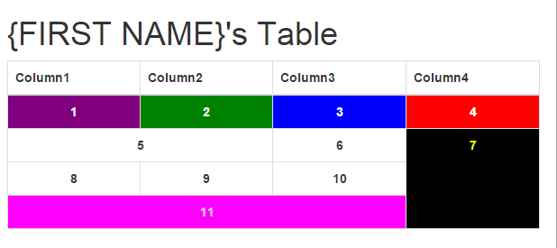

# Submitting

**INSTEAD OF SUBMITTING A ZIP TO COBRA**, when you are done with the assignment, push your code to GitHub. Take a screenshot of the GitHub website showing your commit and submit that to the Cobra Dropbox. Your screenshot will look something like:

